**COMSATS University**

**Islamabad**



**Lab Report # 12**

**Real Time Embedded Systems**

**(EEE-446)**

|  |
| --- |
| **Introduction to IOT using ESP32 Development Board.** |

**Submitted By:**

**Arwa Aamir (FA16-EEE-002)**

**Submitted To:**

**Dr. Ahsen Malik**

# Lab # 12

**Introduction to IoT using ESP32 Development Board**

# Objectives

* Create Hello world program
* Make ESP32 as web server to control data
* Get data from ESP32 on local network

# Tools

* Arduino
* ESP32 Board
* 2 LEDs
* DHT11 sensor

# Pre Lab

Please go through the data sheet of Expressif ESP32 development board.

# Installing ESP32 Add-on in Arduino IDE

To install the ESP32 board in your Arduino IDE, follow these next instructions:

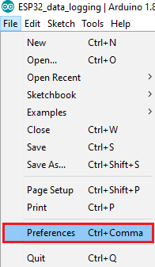

1. In your Arduino IDE, go to **File**> **Preferences**
2. Enter **https://dl.espressif.com/dl/package_esp32_index.json** into the “Additional Board Manager URLs” field as shown in the figure below. Then, click the “OK” button:

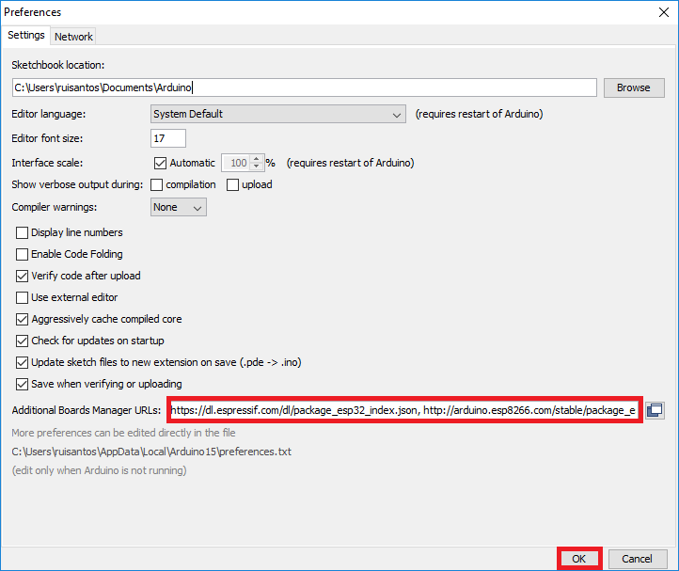

**Note:** if you already have the ESP8266 boards URL, you can separate the URLs with a comma as follows:

https://dl.espressif.com/dl/package_esp32_index.json, <http://arduino.esp8266.com/stable/package_esp8266com_index.json>

1. Open the Boards Manager. Go to **Tools** > **Board** > **Boards Manager…**

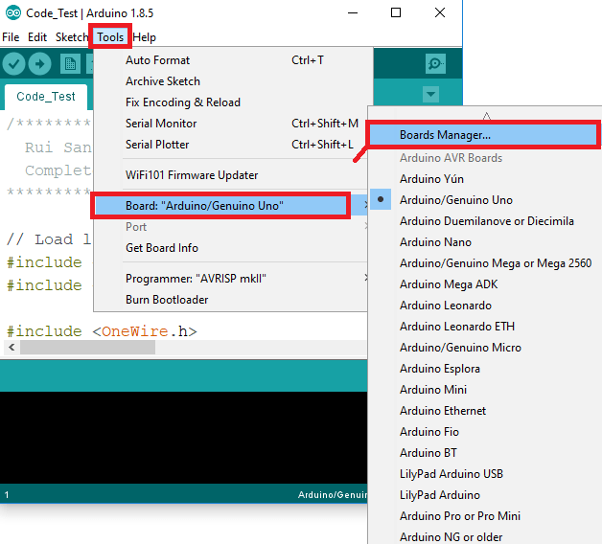

1. Search for **ESP32** and press install button for the “**ESP32 by Espressif Systems**“:

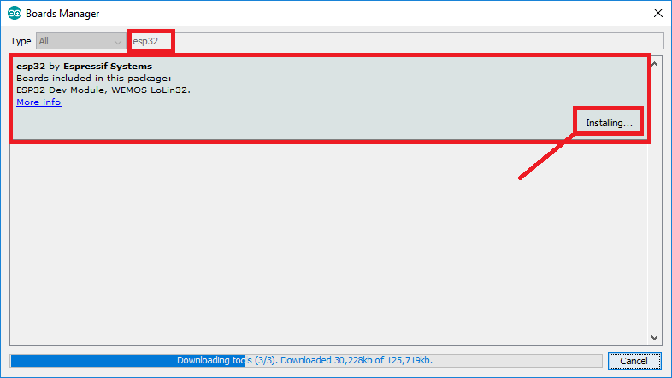

After board installation is complete, write your first led blinking code.

Code: Pin 2 of ESP32 board is connected to LED on Pin 2 by default. int ledPin = 2;

void setup()

{

pinMode(ledPin, OUTPUT);

}

void loop()

{

digitalWrite(ledPin, HIGH); delay(500); digitalWrite(ledPin, LOW); delay(500);

}

### In-Lab Task 1:

Please ESP32 board and run your first program of led blinking on it.

## Hardware Output:

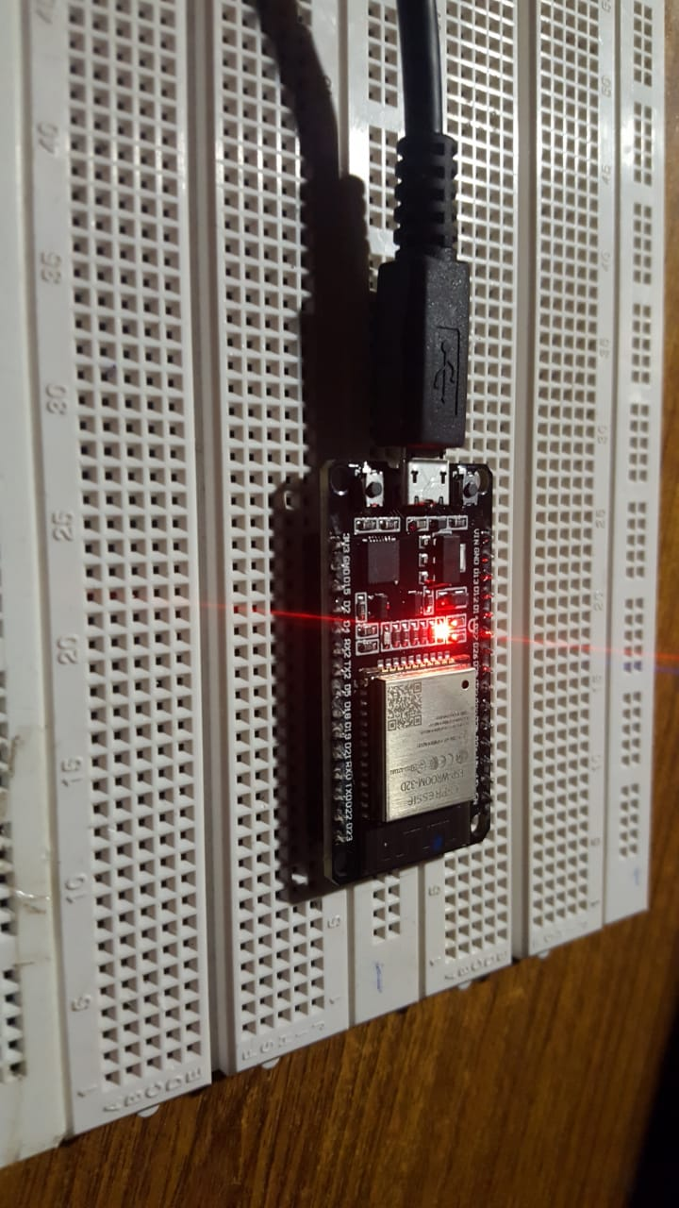

Figure : LED ON

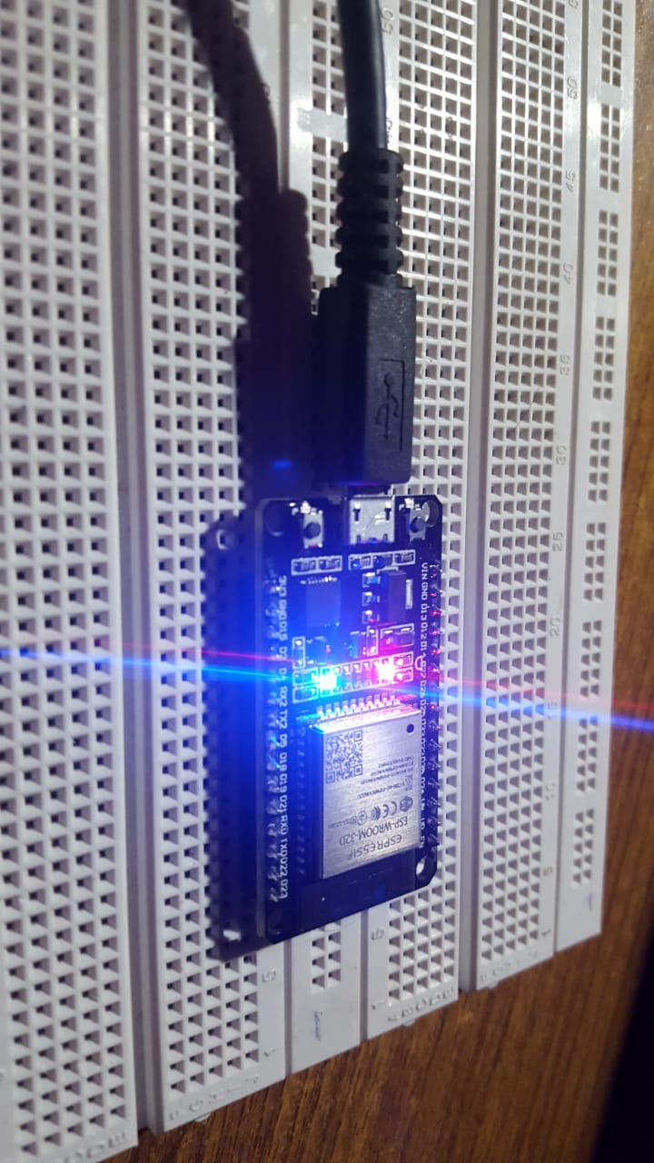

Figure : LED OFF

### In Lab Task 2:

Control of two leds connected at pin 4 and 5 of ESP32 from local server.

## Hardware Output:

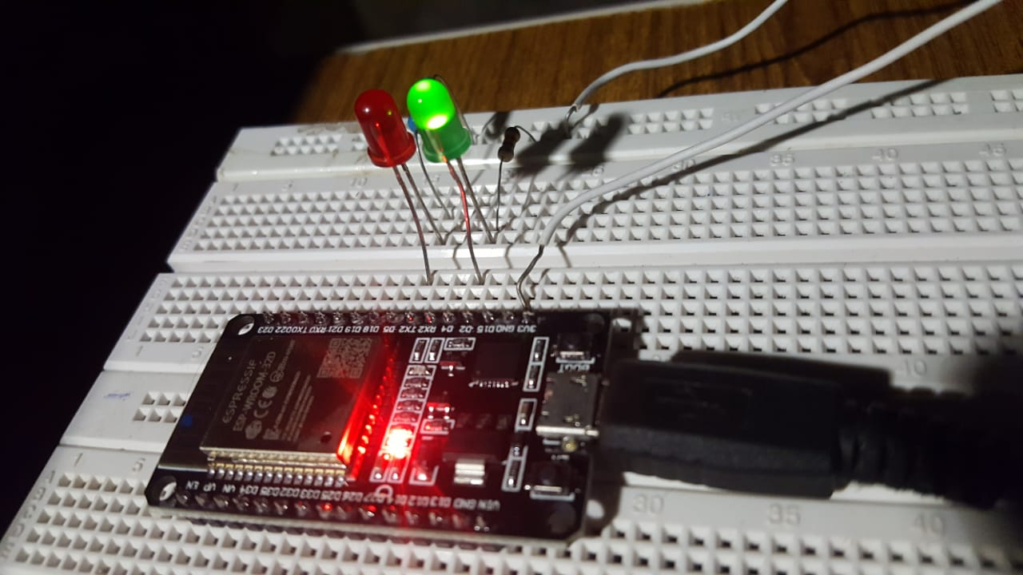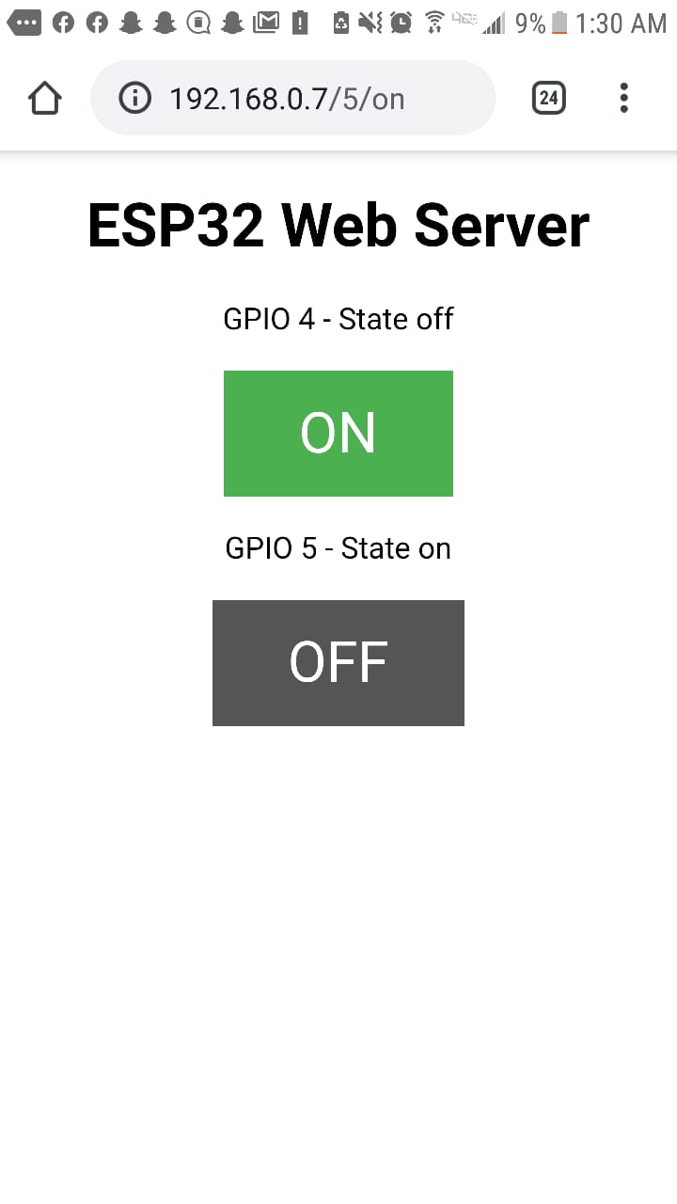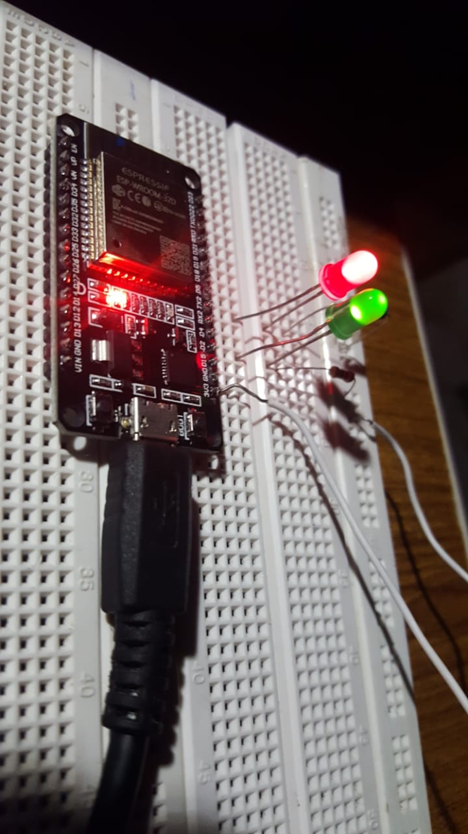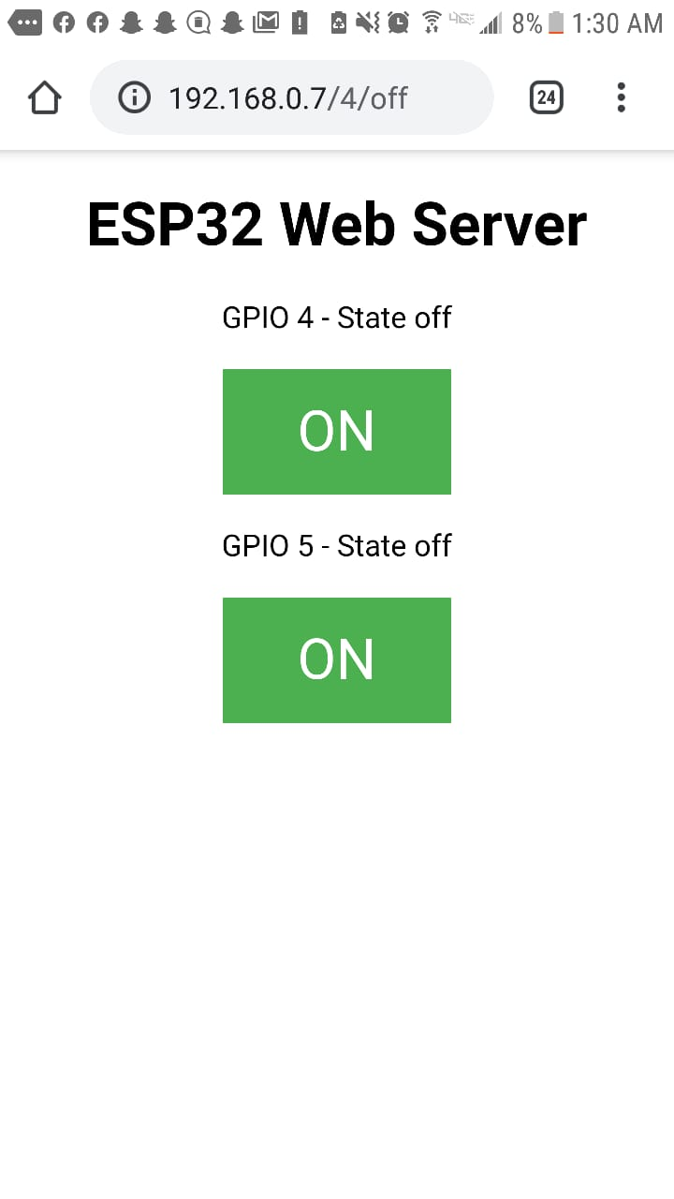

## 

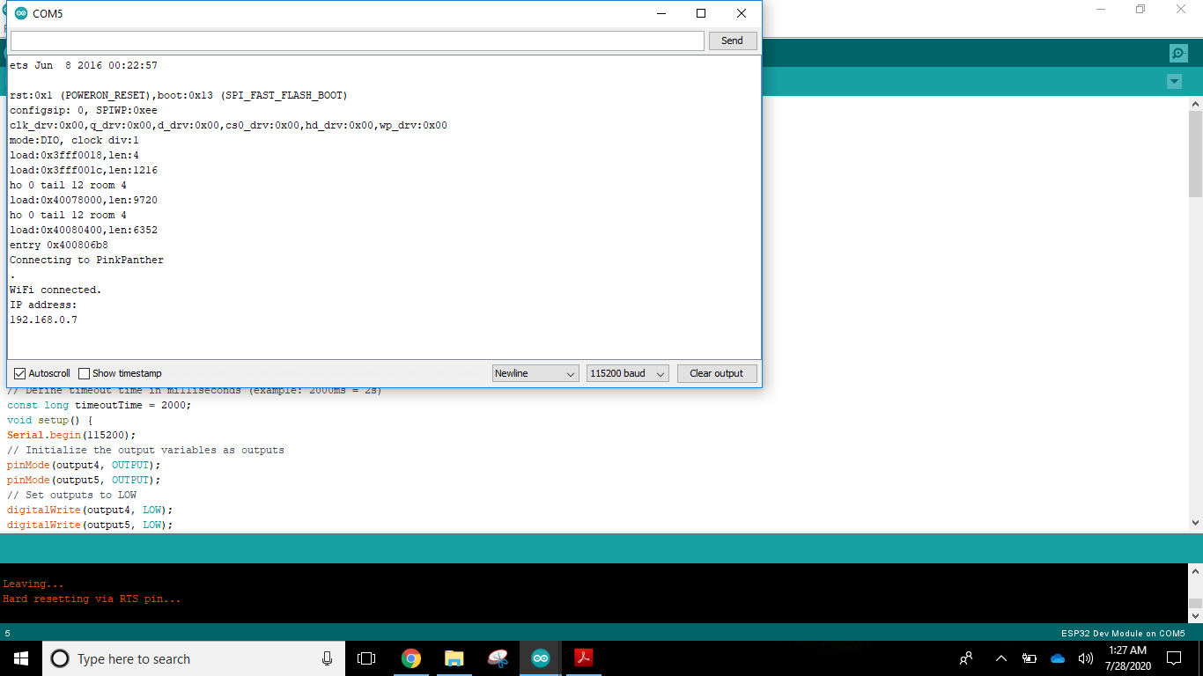

# 

# Conclusion:

|  |
| --- |
| In this lab we learnt how to use an ESP32 and control it’s pins via a local server. |